

Intelligent Vaccine Cold Storage Monitoring System

A REPORT
In
CSA1012 –Software Engineering
Submitted in the partial fulfillment for the award of the degree
Of
BACHELOR OF ENGINEERING
IN
INFORMATION TECHNOLOGY
Submitted by:
N. Srikanth (192411139)

Supervisor/Advisor Name:
Dr. K. Anita Devamani,
Professor/CSE

SAVEETHA INSTITUTE OF MEDICAL AND TECHNICAL SCIENCES
CHENNAI-602105
Section | Title | Page
— | Title Page | 1
1 | Introduction | 2
1.1 | Problem Statement Recap | 2
1.2 | Objectives Mapped to This Assignment | 2
1.3 | System Architecture Overview | 2
2 | Version Control with Git | 4
2.1 | Repository Structure | 4
2.2 | Branching Strategy | 4
2.3 | Core Git Workflow & Commands | 5
2.3.1 | Initializing the repository | 5
2.3.2 | Feature branch workflow (example: ML prediction service) | 5
2.3.3 | Tagging a release | 5
2.3.4 | Hotfix example (critical excursion-detection bug) | 5
2.3.5 | Inspecting history & audit trail | 6
2.4 | .gitignore | 6
2.5 | Commit Message Convention | 6
3 | Containerization with Docker | 9
3.1 | Container Architecture | 9
3.2 | Dockerfile — Sensor Ingestion Service (Node.js) | 9
3.3 | Dockerfile — ML Prediction Service (Python) | 9
3.4 | Dockerfile — Dashboard (React, multi-stage build) | 10
3.5 | docker-compose.yml | 12
4 | Integrating Git and Docker: CI/CD Pipeline | 13
5 | Compliance, Audit & Security Considerations | 14
6 | Conclusion | 14

1.Introduction
The increasing demand for electricity, depletion of conventional energy resources, and growing environmental concerns have created a strong need for sustainable and efficient energy systems. Renewable energy sources such as solar and wind power provide clean alternatives to fossil fuels. However, their variable and unpredictable nature creates challenges in maintaining a stable balance between energy generation, consumption, and grid requirements.
The Smart Renewable Energy Monitoring and Grid Optimization Platform is proposed as an intelligent solution for monitoring and managing renewable energy resources in real time. The system collects data from renewable energy sources, energy storage systems, and electrical loads using sensors and IoT technologies. The collected data can be analyzed to monitor power generation, energy consumption, battery status, voltage, current, and other important electrical parameters.

Problem Statement Recap

The increasing integration of renewable energy sources such as solar and wind into modern power systems has created new challenges in monitoring, managing, and optimizing electricity generation and consumption. Unlike conventional power sources, renewable energy generation is highly dependent on environmental conditions such as sunlight, wind speed, and weather patterns. This variability can result in fluctuations in power generation and make it difficult to maintain a stable balance between energy supply and demand.

1.2 Objectives Mapped to This Assignment
Objective | How Git/Docker Supports It
Continuous monitoring and real-time data collection | Each renewable-energy sensor domain runs as an independent, restart-resilient Docker container, ensuring that data ingestion continues even during deployments or service failures.
Immediate excursion detection & failure prediction | The ML service is maintained under Git version control, allowing models to be retrained, tested, and rolled back independently without affecting other platform services.
Instant multi-channel notification | The notification service is deployed as an independent Docker image/container.
Audit trails & compliance reporting | Git commit history provides a traceable record of application and configuration changes.
Scalable, multi-facility deployment | Docker Compose enables the same set of services and images to be replicated across multiple renewable-energy facilities.

1.3 System Architecture Overview
A platform that monitors renewable energy sources such as solar panels and wind turbines, predicts energy generation and consumption, detects abnormal conditions.
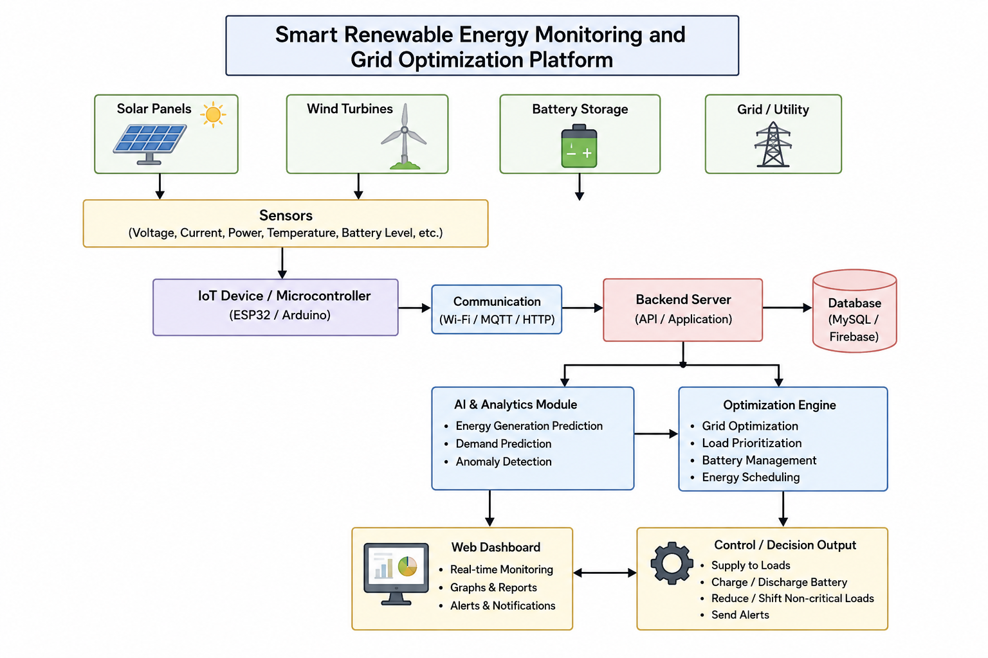

2.Version Control with Git

Git is a distributed version control system used to track and manage changes in software projects. It helps developers maintain different versions of source code, collaborate with team members, and safely manage project development. Git allows users to create branches, record changes through commits, and share code using remote repositories such as GitHub.

2.1 Repository Structure

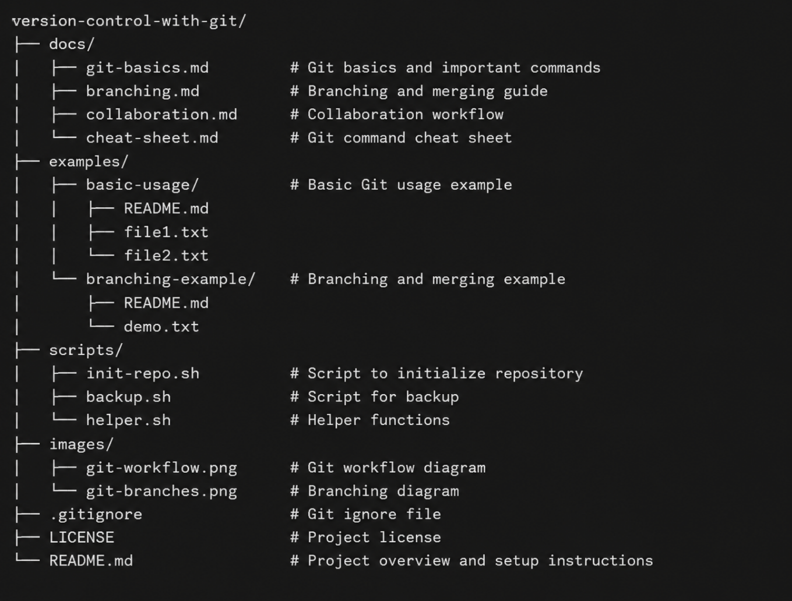

2.2 Branching Strategy
The Smart Renewable Energy Monitoring and Grid Optimization Platform uses a Git branching strategy to organize development and maintain stable project versions. The main branch contains production-ready code, while the develop branch integrates completed features. Separate feature branches are used for modules such as sensor data acquisition, AI-based energy prediction, grid optimization, and dashboard development. After testing and integration, a release branch is created for final testing and preparation before merging the stable version into the main branch.

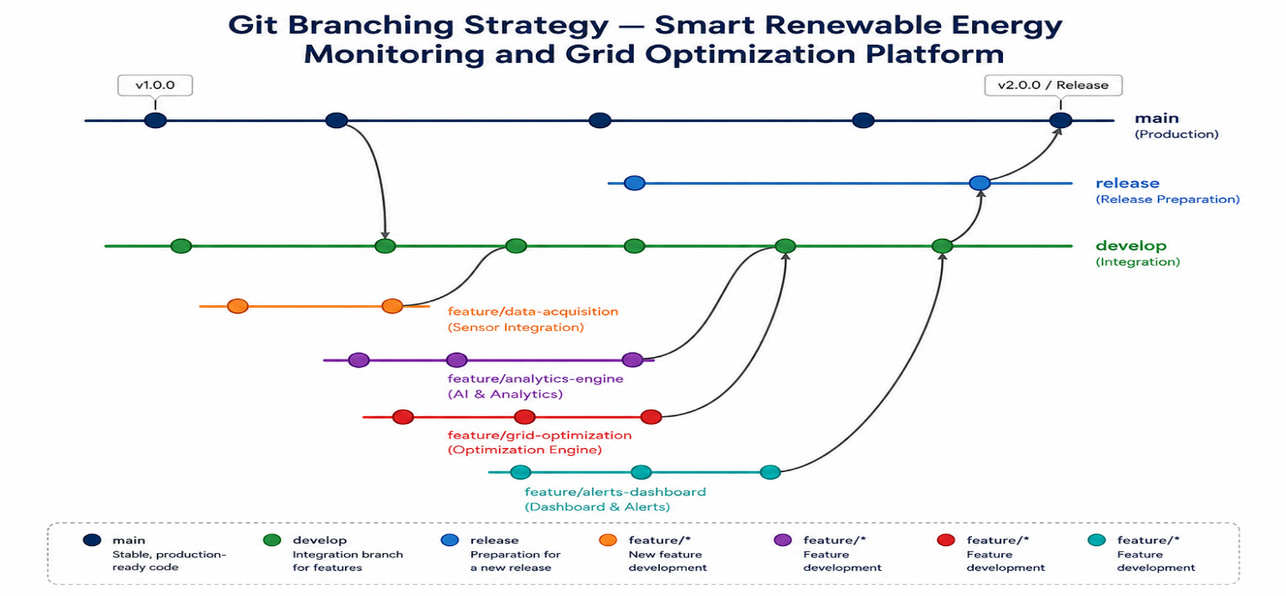

Figure 2. Git branching model used for the monitoring platform.

2.3 Core Git Workflow & Commands
Branch | Purpose | Notes
main | Production-ready code deployed for renewable energy monitoring | Protected; only merges from release/* or hotfix/*
develop | Integration branch for the next platform | Feature branches merge here first
feature/* | One branch for each module or capability | Examples: sensor monitoring, AI prediction.
release/* | Pre-release stabilization and testing | Used for final QA and tagged with a semantic version, e.g., v1.2.0
hotfix/* | Quick fixes for critical production issues | Merged into both main and develop after testing

2.3.1 Initializing the repository

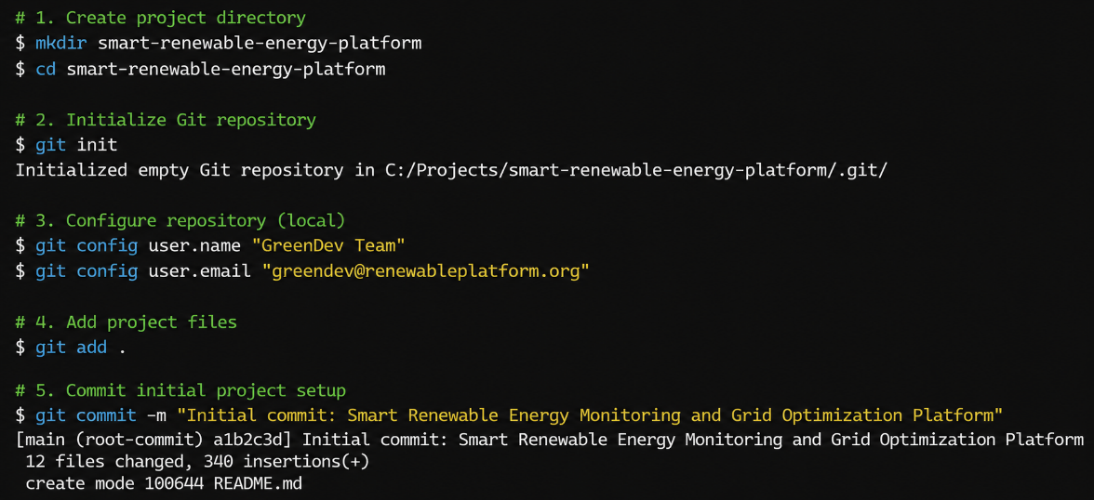

2.3.2 Feature branch workflow (example: ML prediction service)

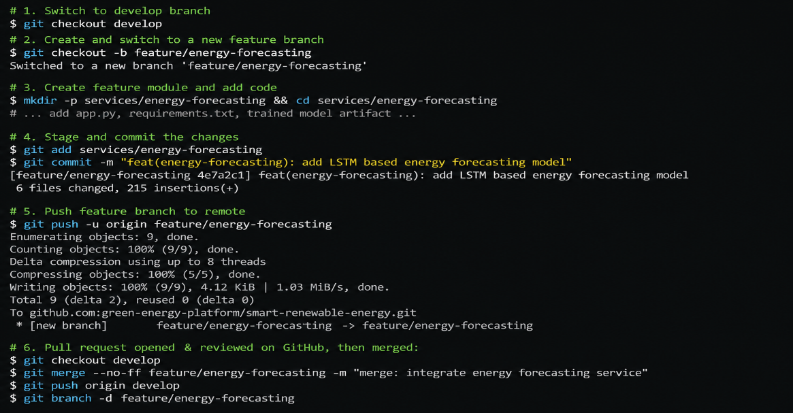

2.3.3 Tagging a release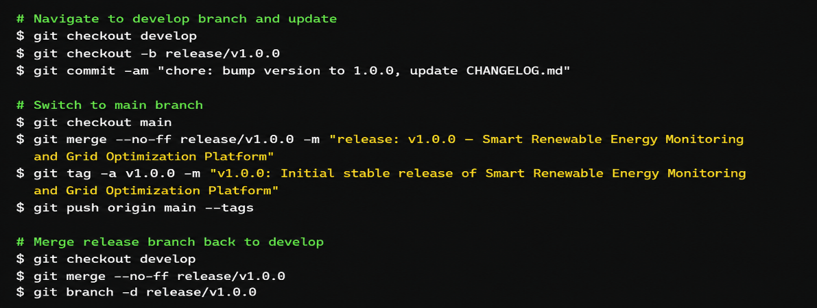

2.3.4 Hotfix example (critical excursion-detection bug)

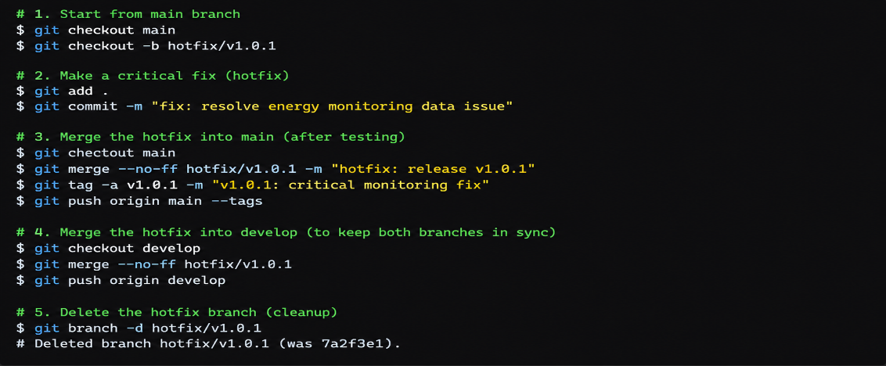

2.3.5 Inspecting history & audit trail

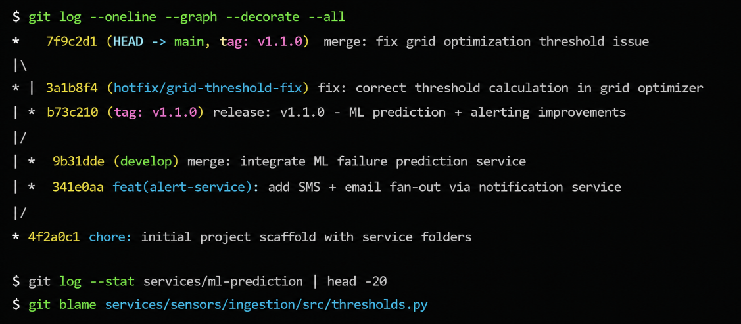

2.4 .gitignore

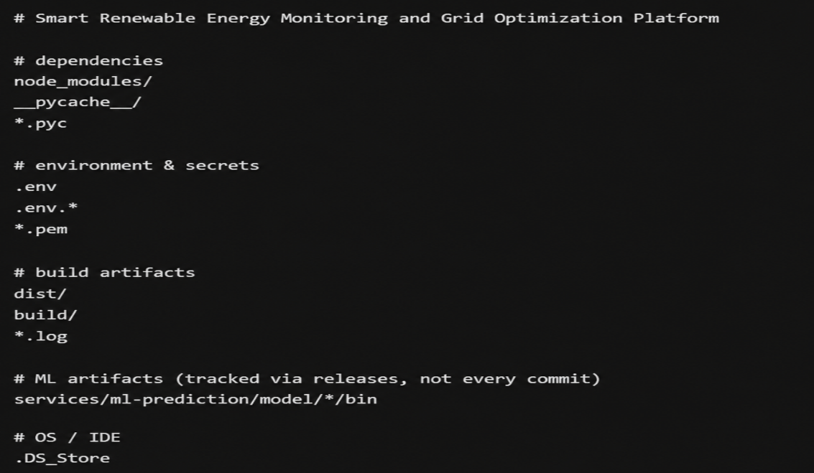

2.5 Commit Message Convention
The team follows Conventional Commits to keep the Git history clear, consistent, and easy to audit. Each commit message clearly describes the type of change made to the renewable energy monitoring, prediction, and grid optimization modules.
Type | Meaning | Example
feat | A new capability | feat(energy-monitoring): add real-time power generation tracking
fix | A bug fix | fix(sensor-service): correct solar sensor data validation
chore | Tooling, config, version bumps | chore(docker): update service container configuration
docs | Documentation only | docs: add grid optimization API documentation

3. Containerization with Docker

The Smart Renewable Energy Monitoring and Grid Optimization Platform uses a container-based architecture to divide the application into independent services. Each service runs in its own Docker container, making the system easier to develop, deploy, scale, and maintain.

3.1 Container Architecture

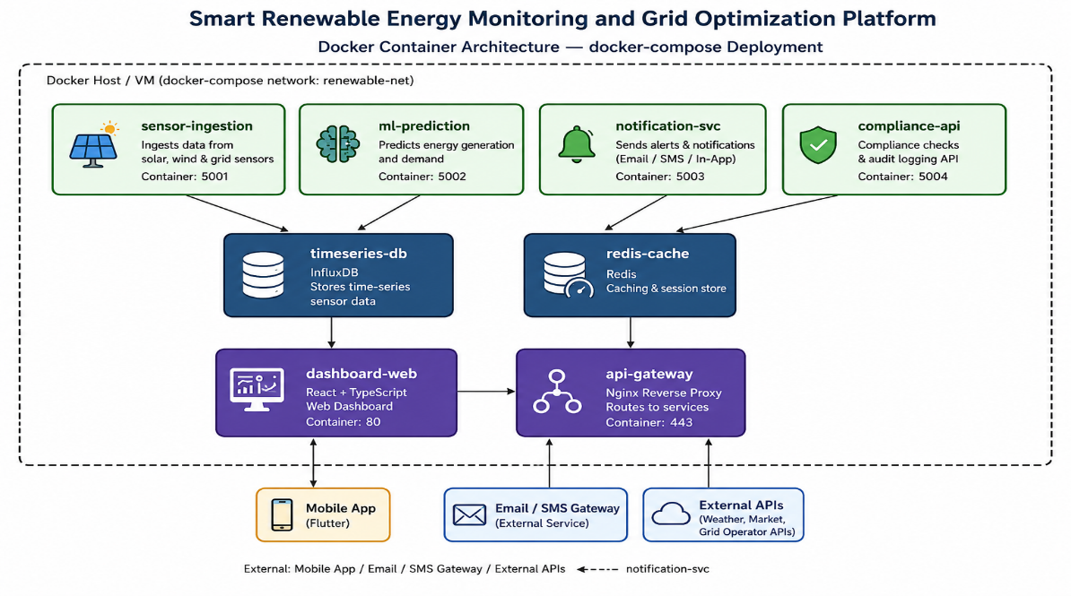

Figure 3. Containerized microservices orchestrated via docker-compose.

3.2 Dockerfile — Sensor Ingestion Service (Node.js)

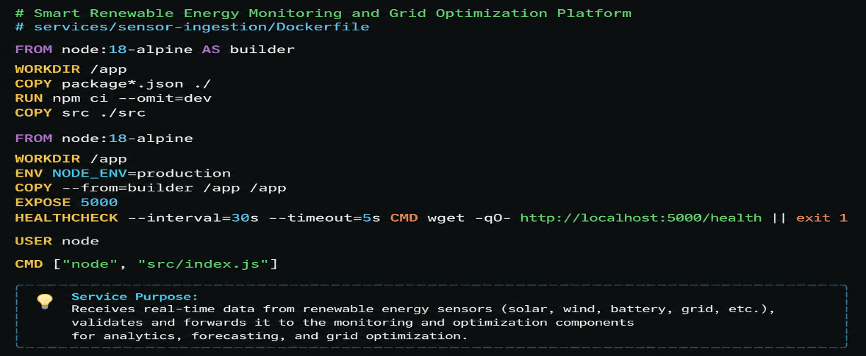

3.3 Dockerfile — ML Prediction Service (Python)

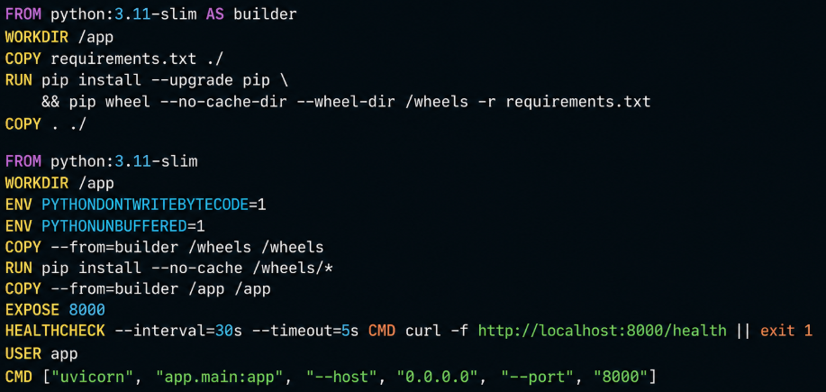

3.4 Dockerfile — Dashboard (React, multi-stage build)

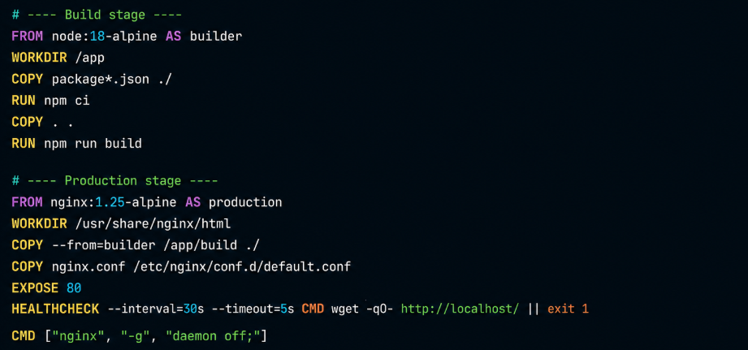

3.5 docker-compose.yml

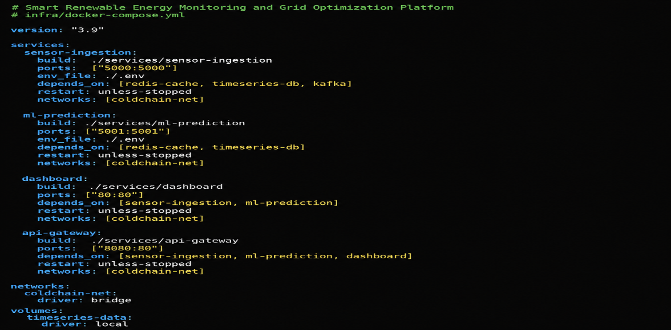

4. Integrating Git and Docker: CI/CD Pipeline
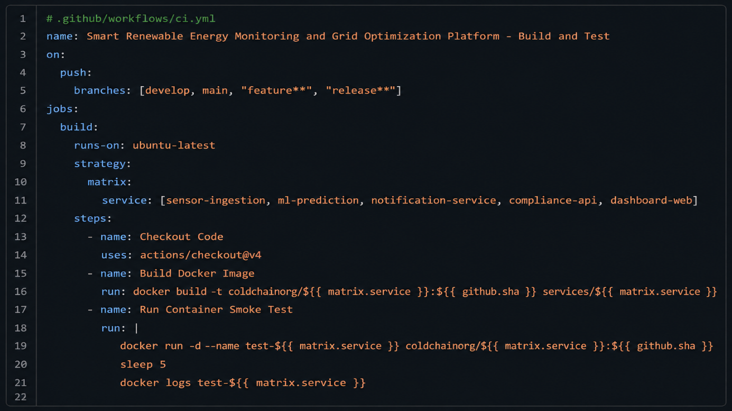The pipeline checks out the latest code, builds separate Docker images for services such as sensor ingestion, ML prediction, notification, compliance, and dashboard, and then runs container-based smoke tests. This ensures that every code change is tested before deployment.

5. Compliance, Audit & Security Considerations

The Smart Renewable Energy Monitoring and Grid Optimization Platform must maintain strong security and auditing practices to protect energy data, system configurations, and operational information.

Access Control: Use role-based access control (RBAC) so only authorized users can access specific services and dashboards.

Data Security: Encrypt sensitive data during transmission using HTTPS/TLS and protect stored data with appropriate encryption.

Audit Logging: Record important activities such as user logins, configuration changes, deployments, sensor updates, and optimization decisions.

Git Audit Trail: Maintain complete Git history with meaningful commit messages, branches, tags, and pull-request reviews.

Container Security: Regularly scan Docker images for vulnerabilities and use trusted, minimal base images.

Secrets Management: Store API keys, passwords, and credentials securely using environment secrets or a dedicated secrets manager rather than committing them to Git.

6. Conclusion

The Smart Renewable Energy Monitoring and Grid Optimization Platform provides a comprehensive solution for monitoring, analyzing, and optimizing renewable energy resources. The platform collects real-time information from solar panels, wind turbines, smart meters, and other energy sensors, allowing users to continuously monitor energy generation, consumption, system performance, and grid conditions.The use of machine learning and data analytics enables the platform to predict energy generation and demand, identify abnormal conditions, and support better decision-making. The grid optimization module can use these predictions to improve energy distribution, balance loads, reduce wastage, and make better use of available renewable power.From a software-development perspective, the project uses Git for version control and follows a structured branching strategy with main, develop, feature, release, and hotfix branches. Conventional commit messages, release tags, audit trails, and .gitignore practices help maintain a clean, traceable, and organized codebase.

